**TITLE : SHEDULING PROBLEMS**

**Description** :

In real life, there are number of works are going in either online or offline.

We are daily using the applications like amazon, flipkart etc. They are delivering the products in right time.

In multinational companies, there are thousands of employees are working but they are assigning a particular task to the employees based on their job.

The works will done very easily when we schedule the jobs properly.

**Problem Statement** :

There are many problems for scheduling the jobs like:

* job shop scheduling
* Travelling salesman problem
* vehicle routing problem
* rig-scheduling problem
* employees scheduling problem

**Example 1:** If we see in companies, there is a problem to schedule the staff in efficient manner. The scheduling of employees is a complex and time-consuming task. It is complex because it involves **assigning the right people to the right job at the right time**. It is conditioned by several legal, work and other organizational rule.

**Example 2:** In the Vehicle Routing Problem (VRP), **the goal is to find optimal routes for multiple vehicles visiting a set of locations** andthe routes with the least total distance.

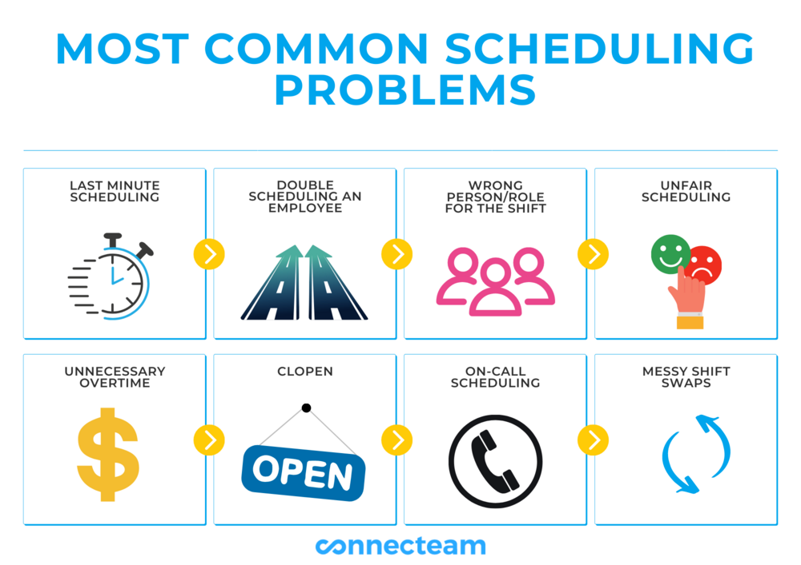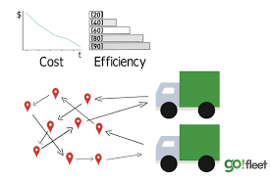

**Employee scheduling problem** **vehicle routing problem**

Our goal of this project is to schedule the jobs of a particular task efficiently.